2022 YARDS IN BLOOM NOMINATION FORM

Your Name: ________________________________________________________________
Deadline for nominations is August 2nd, 2022
● Please select 1 category per address.
● Completed forms can be sent to rvkmbyardsinbloom@gmail.com or dropped off at the Village Office Monday through Wednesday 10am to 4pm.
● Put “YIB Nomination” in the Subject Line of the email.

Address of Yard being Nominated: ________________________________________________
Check 1 only:
☐ Patio
☐ Beds/Raised Beds
☐ Overall Yard
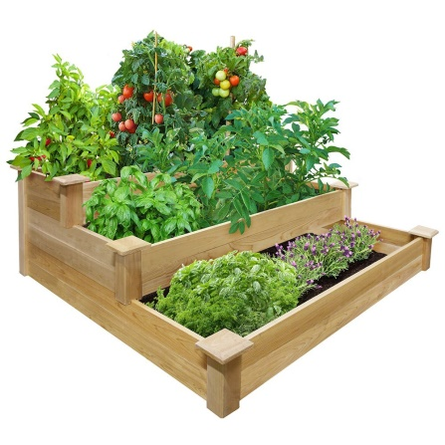
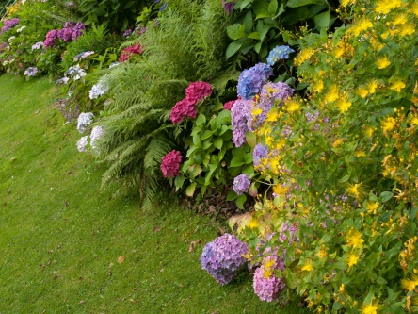
Categories being nominated must be accessible from the beach or roadway – not hidden with fences or gates.
