NEW EVENT
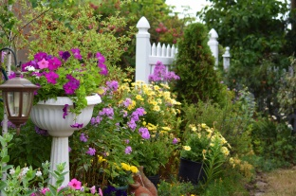
RVKMB YARDS IN BLOOM 2022
Goals
- Recognize our friends and neighbours' efforts to enhance their property and create a more beautiful community
- Encourage community involvement to help keep our village an attractive place to live, work, and play
- Promote beautiful yards that improve the image of our community
- Profile top yards as models for others
- We encourage friends, relatives, neighbours and passers-by to nominate attractive yards in the village. Yards include: patios and raised beds. Nominations will receive recognition by way of a small sign for their yard
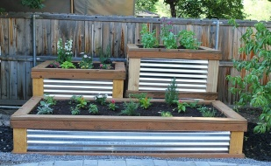
Guidelines
- Anyone can nominate a yard
- You can't nominate your own yard, but you can ask a friend or neighbour to nominate your yard
- Yards in Bloom will have "curb appeal", and so should be in full view from either the roadway or the beach - not hidden with wooden fence or locked gates
- Any yard may be nominated, including side and corner yards, as long as they are visible from the street or beach
Judging
- Volunteer judges visit each yard after the nomination deadline to deliver a yard sign. Judges will select top yards for special recognition
- Utmost respect will be given to privacy during judging
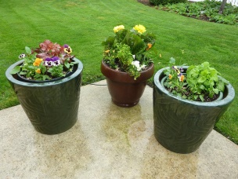
- Judging will take place in late July, early August. Exact dates will be posted on the website
- Visit rvkmb.com in early July for details on how to nominate your favourite yards
- Awards will be presented to the winner in each category; Patio, Raised Bed (Flower or Vegetable) and Yard

