|  |  |
| --- | --- |
| Severe Weather preparedNess  All Seasons | Living in Saskatchewan the weather is always a topic of conversation, from winter chinooks, to autumn Indian summers and the summer thunderstorms. Spring, summer, fall and winter are all so very distinct, and as such their temperatures can fluctuate and often times these are very drastic.  RV Of Kivimaa-Moonlight Bay website: [rvkmb@myaccess.ca](mailto:rvkmb@myaccess.ca)  Office # (306) 845-3336 |

|  |  |
| --- | --- |
|  | Page |
| Table of Contents | 1-2 |
| Severe Weather Preparedness | 3 |
| **Summer Storms**   * Hail Storms * Thunderstorms * Lightning * Thunder * High winds * Plough (Plow) winds * Heat & Humidity | 3-5 |
| Severe Summer Weather Pictures | 6 |
| Preparing for Severe Summer Weather   * Taking shelter * Heat, Humidity, Relative Humidity & the Humidex | 7 |
| Extreme Heat – Definition | 8 |
| What should you do during extreme heat | 8 |
| Signs of heat emergencies & how to treat them   * Heat cramps * Heat exhaustion * Heat stroke | 9 |
| Summer Storm Precautions   * Structures and Vehicles * Personal safety | 10-11 |
| After the Storm | 11 |
| General Precautions to take | 11-12 |
| Responsibility   * Emergency Kits | 12-14 |
| Evacuation – When & How   * When to evacuate * How to evacuate | 14 |
| Extended Power Outages | 15-16 |
| **Winter Weather**   * Wind Chill * Wind Chill Index * Wind Chill Hazards Table | 16-18 |
| Preparing for severe winter weather   * Watch * Warning | 19 |
| Severe Winter Weather Pictures | 20 |
| General Precautions to Take | 21 |
| Before a Blizzard or Winter Storm hits | 21-22 |
| Extreme Cold and Your Health | 22 |
| Signs of Cold Emergencies   * Hypothermia * Frostnip * Frostbite | 23 |
| Treatment of Cold Emergencies   * Hypothermia * Frostnip * Frostbite | 23 |
| Preparing for an Outage | 24 |
| Preparedness for your Pets | 24-25 |
| Special care for other Pets | 25 |
| Preparedness for Livestock | 25 |
| Evacuation | 25 |
| Links | 26 |
| Forms | 27-29 |

**SEVERE WEATHER PREPAREDNESS**

Living in the Prairie Province of Saskatchewan, we are all aware of the changes that can occur in the weather. Storms of all sorts can come up and cause severe damages to property, and in some cases injury or loss of life to the public.

The more severe storms tend to occur in the summer and winter months.

**Summer Weather**

Saskatchewan summers are usually warm and dry, we average the most sunshine of any Canadian province. A normal feature of the summers of Saskatchewan, severe weather can manifest itself in many forms, these include, but may not be limited to;

* Thunderstorms
* Hailstorms
* Plough winds
* Excessive heat, and;
* Tornadoes

**Winter Weather**

With winter lasting on average 6-8 months in Saskatchewan, severe weather can occur any time, and can quickly develop. The severe winter weather can manifest in many forms, these include, but are not limited to;

* Blizzards/Whiteouts
* Ice storms
* Wind chill

In this information booklet on how to prepare for storms throughout the year, there will be descriptions on different weather systems as well as emergency kits to have at the ready for you and your family, including pets and livestock.

The following link will take you to the Government of Canada – Criteria for public weather alerts.

<https://www.canada.ca/en/environment-climate-change/services/types-weather-forecasts-use/public/criteria-alerts.html#severeThunderstorm>

**Summer Storms**

Summer storms in Saskatchewan are generally due to severe thunderstorms. Severe thunderstorms are defined as a thunderstorm producing one or more of the following elements;

* Rainfall of 50mm within 1 hour
* Wind gusts of 90 km/h or greater, which could cause structural wind damage
* Hail of two cm or lager in diameter
* Heavy rainfall as per rainfall criteria
* Tornadoes

Table 1. (Table 13. Canada Environment)

| **Alert type** | **Location** | **Threshold criteria** |
| --- | --- | --- |
| Warning | Alberta, Saskatchewan, Manitoba, Ontario, and Quebec (except Nunavik*) | When 50 mm or more of [rain](https://www.canada.ca/en/environment-climate-change/services/weather-general-tools-resources/glossary.html#wsglossaryR) is expected within one hour. |
| Warning | Interior dry sections of British Columbia | When 15 mm or more of [rain](https://www.canada.ca/en/environment-climate-change/services/weather-general-tools-resources/glossary.html#wsglossaryR) is expected within one hour. |
| Warning | Remaining sections of British Columbia, Yukon, Northwest Territories, Nunavut, New Brunswick, Prince Edward Island, Nova Scotia, Newfoundland and Labrador | When 25 mm or more of [rain](https://www.canada.ca/en/environment-climate-change/services/weather-general-tools-resources/glossary.html#wsglossaryR) is expected within one hour. |

*Hailstorms*

Hail is formed when updrafts in thunderclouds carry raindrops upward into extremely cold areas of the atmosphere, upon which they freeze and form into clumps of ices. When the clumps of ice become to heavy to be supported by the updraft, they will fall to the ground reaching speeds of up to 100 km/h or more. In areas of Canada, there have been reports of hailstones as large as grapefruits, hail this size can cause extensive and severe damage, smaller hail can also cause damage. These storms generally occur from May to October. These storms are most frequent in Alberta and in the southern parts of the Prairies, all though the north and central areas have been subject to damaging hail storms.

*Thunderstorms*

A thunderstorm is a localized storm that produces lightning and thunder. Caused by strong, rising air currents, thunderstorms are most likely to develop when the weather is hot, humid and hazy. Thunderstorms are a common in Saskatchewan during the summer months. Often characterized by heavy rain and strong winds, they can sometimes be accompanied by hail and tornadoes or plough winds.

*Lightning*

Lightning is an electrical discharge caused by a build-up of static electricity between thunderclouds, or between thunderclouds and the ground. It can deliver as much as 100 million volts of electricity and strike an object up to 16 kilometres away, resulting in an extremely dangerous form of severe weather.

*Thunder*

Thunder is the result of when air suddenly expands from the heat of a lightning discharge. If you can hear the thunder you are within striking distance. If you count the seconds between the flash of lightning and the thunder clap, it will give you a rough estimate of the distance the lightning strike was from you. To figure this out, each second from the time of the strike equals approximately 300 metres (1/2 mile) – example;

* 5 seconds between lightning and thunder = a distance of 2.5 miles away (4km)

*Wind*

A strong wind not only occurs on a large scale from a large storm or low-pressure system and fronts, but also on small scale from thunderstorms. Strong winds especially gusty winds, can cause property damage or turn any loose item into a dangerous projectile and create unsafe travel conditions, which can affect a person’s ability to control their vehicle while driving.

*Plough Winds*

Plough winds are the result of a spreading downdraft and strong straight-line winds preceding a thunderstorm. The downdrafts rush to ground with force, often times at speeds of 100-150 km/h winds. When they reach the ground, the air spreads horizontally in a burst if wind. A plough wind can blow continuously but the damage is usually confined to an areas less than 3 km across. A plough wind is capable toppling trees, ripping apart buildings and lifting roofs. Plough winds and other downbursts are often times responsible for some damage that is attributed to tornadoes. Plough winds are more common than tornadoes, and have the power of a weak tornado. The damage from a plough wind looks different – a circular or semi-circular swath left by tornadoes and a starburst or more commonly a straight-line pattern from downbursts.

*Heat & Humidity*

Humidity – the amount of water vapour in the air.

Relative humidity describes the percentage of moisture in the air in comparison to how much there is when the air is saturated. Canadian Meteorologists have developed the humidex, a parameter that combines temperature and humidity in order to reflect the perceived temperature. When the humidex is high people can experience serious health problems such as cramps, exhaustion and heat stroke.

***Lightning or downed power lines can lead to fire.***

**Severe Summer Weather Can Lead To…**

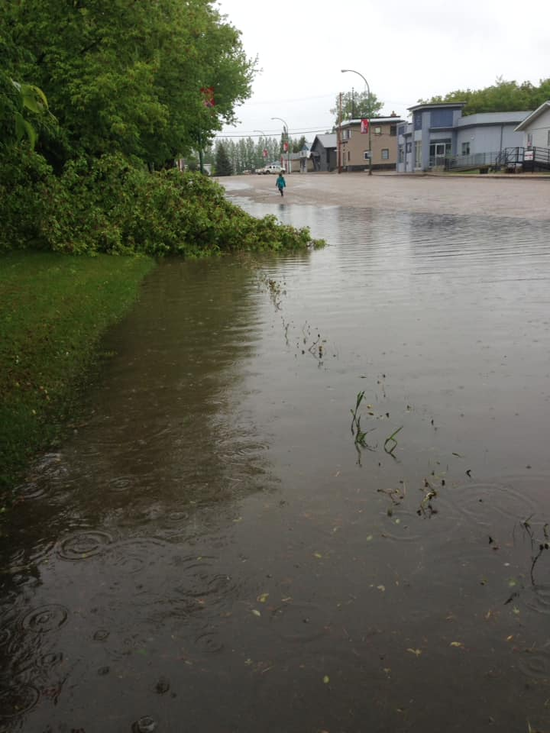 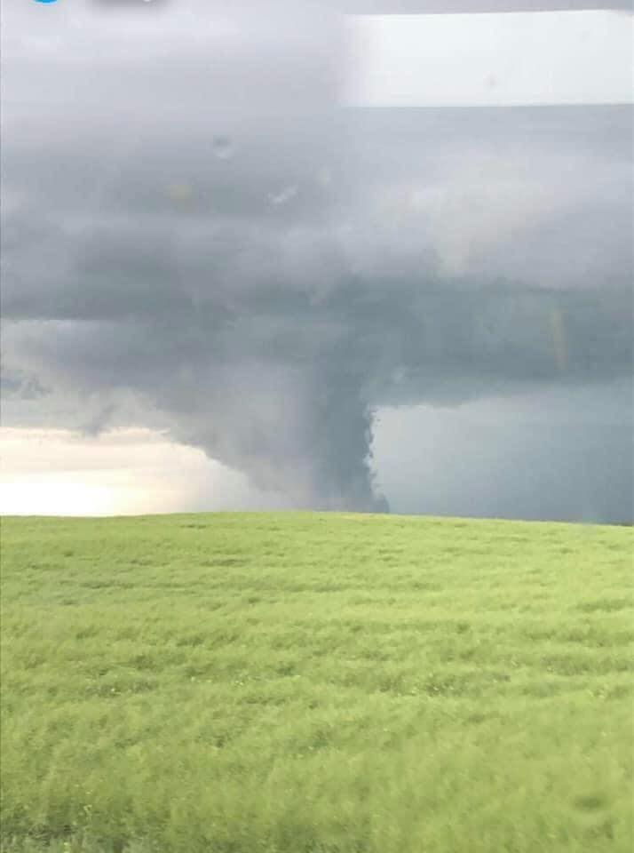

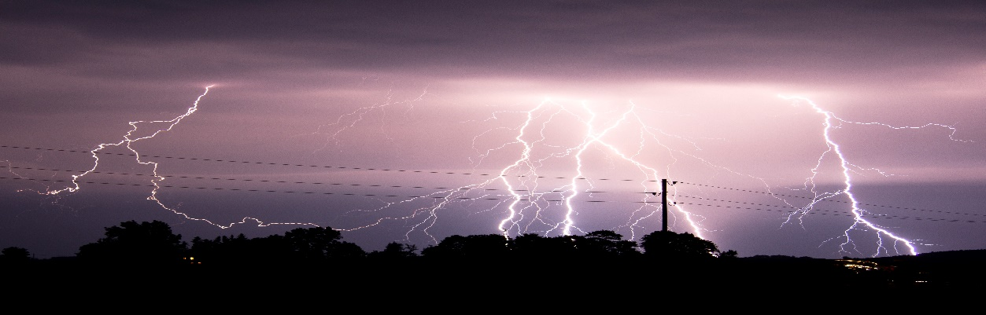

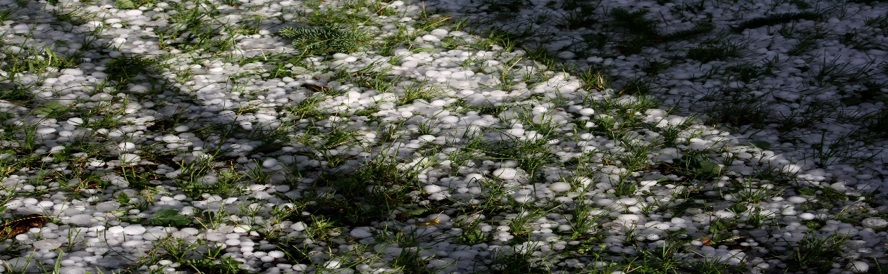

**Preparing for Severe Summer Weather**

Severe can often times sneak up unexpectedly. There are times when there are clues in the sky that may alert us to a change in weather or that a severe storm may be on its way.

Environment Canada releases alerts when any form of Severe Weather is imminent. These alerts can be issued through any of the following;

* SaskAlert – App available for free to any iPhone or android users
* The Weather Network – App available for free for any iPhone or android users
* Radio broadcasts – this includes alerts posted on Social Media by Radio Stations
* Television stations

*Taking Shelter*

When the alerts for any form of severe weather are issued, you should be looking for shelter. Safe shelter areas;

* House
  + Basement
  + Interior room in the centre of the house (closet, bathroom or hallway)

Unsafe areas to seek shelter

* Large buildings with unsupported roofs
  + Arenas
  + Supermarkets
  + Barns

If you are boating or swimming head for land immediately, DO NOT TRAVEL.

*Heat, Humidity, Relative Humidity and the Humidex*

Avoid working or exercising intensely if it is a very hot or humid day. Head for cooler conditions if your body becomes overheated. If you are required to work outdoors ensure to keep yourself properly hydrated, take breaks in shaded areas. Be sure to maintain salt levels in your body and avoid high-protein foods. Beverages such as Gatorade or PowerAde have electrolytes that aid in the hydration of the human body.

Relative Humidity is the amount of moisture that the air contains compared to how much it could hold at a given temperature. A figure of 100% relative humidity would mean that the air has become saturated. At this point mist, fog, dew and precipitation are likely.

The humidex is a Canadian innovation that was first used in 1965. It describes how hot, humid weather feels to the average person. It combines the temperature and humidity into one number to reflect the perceived temperature. The humidex is widely used in Canada and generally decreases as latitude increases.

**Extreme Heat**

Saskatchewan at times experiences high heat temperatures that reach upwards of 30° Celsius. Heat waves are a prolonged period of high temperatures and humidity which is made worse if you are in the sun, or there is little to no wind.

As per Environment Canada a;

Heat Wave is defined as;

*“two or more consecutive days of temperatures at 30 degrees Celsius, 86 degrees Fahrenheit or above’ June 18, 2020.*

Extreme Heat is defined as;

*“A period of high heat and humidity with temperatures above 32 degrees Celsius or 90 degrees Fahrenheit for at least 2 days”*

There is also typically a lack of night time cooling and air quality is often poor. The Metrological Service of Canada may issue a humidex advisory.

High humidity and high heat make it hard for the human body and for animals to cool themselves. Under normal conditions, the body’s internal thermostat produces perspiration that evaporates and cools the body, however, in extreme heat and high humidity, the body must work harder to maintain normal temperatures. The most vulnerable are infants, elderly and the sick, especially those without air conditioning.

*What Should you do during extreme heat temperatures*

* STAY OUT OF THE SUN
* If you go outside stay in the shade
* Drink lots of water, do not wait until you are thirsty
* Keep house cooler than the outdoors
  + Heavy curtains
  + Air Conditioner
  + Doors and windows closed (unless there is enough of a cross breeze)
  + Lights turned off
* Dress appropriately
  + Loose-fitting clothing
  + Lightweight clothing
  + Hats with wide brims
* Take a cool shower or bath
* Eat small meals more often
* If the night temperature is cooler than the days, open the windows and use fans to bring the outside temperature inside.
* Limit physical activity during the day
* Liquids that are high in sugar and/or alcohol content should be avoided as they may increase the amount of water that is lost by your body.
* If you experience heat cramps, are advised by your doctor or have to work in the heat and are sweating a lot, you may want to take in extra salt.
* NEVER leave children, the elderly or pets unattended in a car, even with the windows rolled down.

*Signs of heat emergencies and how to treat them*

Watch for signs of the following;

**Heat Cramps**

* Painful cramps in the stomach, arms and legs
* May occur suddenly
* Cramps are a warning that more serious heat disorders may occur if stress continues;
  + Move the person to a cooler place
  + Have them rest in a comfortable position
  + Lightly stretch the affected muscle and replenish fluids
  + Give a half glass of cool water every 15 minutes
  + Have them drink cool salted water (1 tsp salt/gallon of water
  + Do NOT give fluids with alcohol or caffeine as they can make conditions worse
* If symptoms do not improve, or worsen call 911

**Heat Exhaustion**

* Present like they’re in shock
* Cool. Moist, pale or flushed skin
* Headache
* Nausea or vomiting
* Dizzy and exhausted
* Upset, clumsy, confused, blurred vision and panting
  + Move the person to a cooler place
  + Remove or loosen tight clothing
  + Apply cool wet cloths
  + If they’re conscious, give them water every 15 minutes
  + Have them drink cool salted water (1 tsp salt/gallon of water
  + Do NOT give fluids with alcohol or caffeine as they can make conditions worse
* If symptoms do not improve, or worsen call 911

**Heat Stroke – is a life-threatening situation**

* Hot, dry red skin
* Changes in consciousness
* Rapid and weak pulse
* Breathing is shallow and rapid
* Body temperature is high - 40°C (105°F)
* May be confused and or dizzy
  + Call 911 immediately
  + Move the person to a cooler place
  + Attempt to cool the person using wet cloths
  + Watch their breathing for changes
  + If the person refuses water or is vomiting or there are changes in the level of consciousness, do NOT give them anything to eat or drink.

**Summer Storm Precautions**

There are steps that each homeowner/renter can take to limit the damages from summer storms.

*Structures & Vehicles*

* Remove dead or rotting trees/branches that could fall or cause an injury or damage during a storm.
* Keep rain gutters and drainpipes clean so water can drain quickly.
* Secure or store outdoor objects that could blow away or cause damage.
* Make sure your roof is in good repair
* Unplug all electronics, i.e. T.V., radios, appliances, computers, air conditioners, etc. power surges can cause serious damage
* Stay away from items that conduct electricity if a thunder/lightening storm is predicted
* Pull vehicles, boats, campers in a covered area if possible
  + Shutter windows and secures outside doors and close window blinds, shades etc.

*Personal Safety*

* Follow the 30/30 Lightening Safety Rule;
  + Count the seconds between seeing the lightning flash and hearing the thunder clap. Each second represents about 300 meters. If this time is 30 seconds or less, then the lightning storm is less than 10km away and there is an 80% chance that the next strike will happen within that 10km. Seek shelter immediately, in a building is preferable.
  + 30 minutes after seeing the last lightning flash or thunder clap, wait 30 minutes before leaving your place of shelter. More than half of lightning deaths occur after the thunderstorm has passed.
* Use corded phones for emergencies only. Cordless and cell phones are safe to use.
* Avoid showering or bathing during a lightning storm
* Avoid the following;
  + Natural lightning rods such as;
    - tall isolated tree in an open area
    - open fields
    - hilltops
    - the beach or boat on water
    - isolated sheds, small structures in open areas
  + Anything metal
    - Tractors
    - Farm equipment
    - Motorcycles
    - Golf clubs etc.
  + Collecting any laundry that may be hanging outside
* Use battery operated radio for updates from local officials.
* Never go out in a boat during a storm, if you are on the water and bad weather is on the way in, head to shore immediately. Always check the forecast before heading out on the water for the day. Be sure to inform someone if you’re planning on heading out onto the water (where and ETA back to shore)
* If driving pull, over to the side of the road, preferably under an overpass or shelter
  + DO NOT STOP at a clump of trees or near powerlines that may fall on you.
* If caught in the open, take shelter in a depressed area such as a ditch – DO NOT LIE FLAT ON THE GROUND.
  + Minimize your contact with the ground by making yourself a smaller target by crouching with your feet close together, and head down (leap-frog position)
* Stay away from streams and rivers in the event of flash flooding (no matter where you are, especially if you are unfamiliar with the area.)

*After the Storm*

When a storm has ended, you should still listen or watch for alerts and updates to notify the public of any damages or threats that may still exist.

The following is a list of do’s and don’ts after the storm

* Do not go near loose or dangling power lines
  + Report these to SaskPower
* Lightning and downed lines are a fire hazard, if a fire is spotted call 911 and report the location of the fire. If the fire is small and NON-electrical you can attempt to put out the fire.
* Check your property for damage to structures, trees, vehicles
* Water supplies may be contaminated purify your water by;
  + Boiling it for 10 minutes
  + Add water-purification tablets
  + OR add one drop of unscented chlorine bleach to one litre of water (or three drops if the water is very cloudy)
* If you have to travel, driver carefully and only if necessary
  + Downed power lines, debris and washouts will make driving dangerous after a severe storm.
  + Remember to give way to emergency vehicles at all times
* Take photos and videos of your property if the damage is severe and get in contact with the insurance agency.

*General Precautions to Take*

If you live in a high-risk area for severe summer weather, or even if you travel to areas that are high-risk having a plan and knowing the area that you are traveling to emergency plans are, is good to have.

The following is list of precautions to take;

* Prepare a family plan
  + Keep this plan updated and in an easy to find place (with your emergency kit)
  + Photocopy your plan or add it to your notes on your iPhone, android, iPad or tablet.
* Include in your plan
  + Contact information
  + Copies of important documents
    - Will
    - Insurance policies
    - Contracts deed
    - Passport
    - SIN cards
    - Immunization records
    - Bank information
  + Evacuation routes – out of house and out of yard
  + Your local Emergency Planning Committees evacuation centre(s)
  + Outside contact information (extended family or friends)
    - Phone numbers and address
  + How to communicate with immediate family members should you become separated.
    - Ensure children know mom and dads phone numbers
    - If possible, have them know their grandparents/aunt/uncles phone numbers
* Prepare an emergency kit for;
  + Home (enough for all members of the household)
  + Pets
  + Car
  + Grab and go kit
* Move or secure any lawn furniture including
  + Chairs
  + Tables
  + Gazebos
  + Planters
  + Shutters
* Secure
  + Trash cans
  + Trailers
  + Propane tanks
  + Augers
  + Lawn mowers (push and riding)
* Trim/Repair/Fill
  + Branches
  + Shingles
  + Fill troughs barrels etc. with water to secure in place
* Make Plans for livestock
  + Water & feed
  + Shelter
  + Transportation (in the event flood, fire, etc.)

*Responsibility*

Although the RM of Turtle River No.469 and the Village of Edam have an Emergency Planning Committee that has prepared for these types of situations, it is also your responsibility to protect you and your family including your pets and livestock.

Agencies from all levels of government can do their jobs efficiently if each one of us takes a personal responsibility for preparedness. By ensuring we are prepared, our family friends and neighbours are prepared, and being able and willing to help the aforementioned it will help to reduce the devastating effects of disasters.

*Emergency Kit*

When creating an emergency kit, it should be able to sustain you and your entire family for 72 hours. When an emergency occurs, the emergency workers focus on the people who are in urgent need.

*Basic Emergency Kit*

Many of the items required in an emergency kit are found in your homes’. The key is to make sure they are organized, easy to find and easy to carry in case you need to evacuate your home.

House hold kit should include;

* Water – 2 litres of water per person per day (include small bottles)
* Food – canned food, energy bars, fried foods (replace once a year if not used) any food stuff that won’t spoil.
* Manual can opener
* Wind-up or battery-powered radio (include extra batteries)
* First aid kit
* Special needs items
  + Pet food
  + Prescriptions
  + Medications
  + Infant formula (if you have infants)
* Extra keys for house and vehicles
* Cash – smaller bills
* Emergency plan

Additional Items to consider;

* Two additional litres of water/person
* Candles, matches, lighter
* Change of clothing and footwear (seasonal)
* Sleep bag, warm blanket for each member
* Toiletries
* Hand sanitizer
* Toilet paper
* Utensils
* Garbage bags
* Household chlorine bleach or water purification tablets
* Basic tool kit
* Small propane camp stove
* Whistle
* Duct tape
* Phone chargers

Emergency Vehicle Kit (Seasonal supplies)

* Food – that won’t spoil
* Water
* Blanket
* Extra clothing and shoes
* First aid kit (with seat belt cutter)
* Small shovel, scraper and snowbrush
* Candle in a deep can, matches
* Wind-up flashlight
* Roadmaps
* Copy of your emergency plan and personal documents

Additional items (Seasonal Supplies)

* Sand, salt, noon-clumping kitty litter
* Antifreeze, windshield washer fluid
* Tow rope
* Booster cables
* Fire extinguisher
* Warning lights or flares

**Evacuation – When & How**

When an emergency occurs, and there is a significant threat posed to the community or residents in the rural areas, Council will need to declare an emergency, and the Emergency Operations Centre will be activated.

*When to Evacuate*

* Evacuate only when instructed to do so by your Emergency Planning Committee members
* If ordered to evacuate, listen to media reports, check the SaskAlert App to learn about areas being evacuated and which routes are the safest to take.
* Evacuation orders are broadcast through the media or delivered directly to the affected persons homes and businesses by any of the following;
  + Emergency Planning Committee
  + Emergency Responders (Fire Department, RCMP, etc.)
  + Council Members
* If notice to prepare for an evacuation is given, ensure that you have all of your essential items ready to go, (Emergency Kit etc.)

*Ordered to Evacuate*

* Ensure that you have your family emergency kit and important documents (Medical and vaccine information)
* Check with your neighbours to see if they require assistance, remember – Protect yourself and your family first.
* Wear comfortable and appropriate clothing and footwear
* Check that arrangements made for pet & livestock (should be done when creating/building your emergency kit) is still in place
* Shut and lock all doors and windows including barn doors and gates.
* Shut off water supply, natural gas and power to all buildings and out buildings
* Evacuate via the route exactly as directed.
* Remain calm and do not speed, obey official directions as some roads may be closed or rerouted.
* DO NOT TAKE SHORTCUTS
* Report to designated reception centres, if you have an alternate location to stay, still call and report in to the Reception centre so that they know your location and that you and your family are safe and not sending volunteers out to search for you.

**Extended Power Outage**

Power outages are often times, a side affect of the Severe Storm, no matter the season. Most times an outage will be over almost as soon as it begins. Some power outages can last much longer, especially in rural areas. During a power outage, you may be left without heating, cooling of your house, no lighting, hot water and no running water.

In order to be better prepared in the event of a power outage here are some steps you and your family can take to be ready;

* Wood stove or fire place – have the chimney cleared annually, and ensure you have a good supply of wood to last at a minimum of 72 hours.
* Install an emergency generator
* Plug in all sensitive electronic equipment through a surge protector bar.
* If you require electronic life-sustaining equipment, make sure to have a back-up power source.
  + *You can also register your life-sustaining equipment with SaskPower and be notified of planned power outages.*
* Be sure to program **310-2220** into your cell phone
  + This number is dedicated to reporting and updating the public on power outages by SaskPower and is 24 hours.
* If you have a land line, be sure to keep a corded phone in your house, as cordless phones do not work when the power is out.

*When the power goes out and is an unplanned outage;*

* Determine if the power failure is limited to just your house/acreage/farm or if it affects the neighbours. If it is affecting just your property, check the main circuit breaker to see if it has tripped, turn the breaker off and back on again to ensure a good connection.
* If the resetting of the main circuit does not work, contact SaskPower at **310-2220** and report the issue.
* Turn off or unplug and appliances or electronics you were using when the power went out
  + Leave only one light on so you’ll know when the power comes back on.
* Keep fridges and freezers closed, if the power is out for an extended time, be sure to check all food before consuming to ensure it has spoiled.
* Can use lanterns or candles for light during the outage, be sure to;
  + Use proper candle holders
  + Proper kerosene for lanterns
  + Extinguish when no longer required (going to bed, heading outside, etc.)
* NEVER light a fire inside the house, unless you have a wood stove or fireplace installed.
* Make sure your home has a working carbon monoxide detector
  + If it is hardwired to your house’s electrical supply, be sure to check the battery back up

*When power is restored*

* If everyone’s power has returned but your own, there could be a specific problem at your location.
  + Recheck your main circuit breaker even if it appears to be on
  + If power is not restored, call SaskPower @**310-2220**
* Allow the electrical system a chance to stabilize
* Wait 15 minutes before turning up any thermostats
  + Turn the heating system thermostats up first,
  + Reconnect fridge and freezer(s)
  + Turn on other essential appliance and equipment first and wait another 10-15 minutes before turning on the rest.
* Do not enter a flooded basement
* Do not use any electronics that were flooded, including electrical outlets, switch boxes or fuse-breaker panels until they have been cleaned and inspected by a qualified electrician.
* Check your food supplies in the fridge or freezer(s) as well as in the cupboards, for signs of spoilage
  + If the freezer door is kept closed in an extended power outage for 24-36 hours depending on outside temperature, the food should still be frozen.
  + If the food is just starting to thaw, it should be cooked to prevent spoiling and then refrozen.
* As a general precaution, keeping a bag of ice cubes in your freezer can aid you in determining if the freezer was off due to power outage;
  + If the ice melted and refroze, it is a good indication that your food may have spoiled and to check it all out and toss what is no longer edible.
  + WHEN IN DOUBT THROW OUT!
* Reset your clocks, timers and alarms.
* Restock whatever items were used out of your emergency kit.

**Winter Weather**

Saskatchewan winters normally begin in November, but for the most part by mid-October temperatures remain below freezing over night, and snow is covering the ground. Winter is very cold, with January and February being the coldest and driest months of the year. Temperatures can reach as low as -35°C to at times -50°C.

*Wind Chill*

* The temperature the body feels when the air temperature is combined with the wind speed
* Based on the rate of heat loss from exposed skin caused by the effects of wind and cold, as the speed of the wind increases, it can carry heat away from the body much more quickly
* High winds can cause weather-related health problems even when temperatures are only cool

*Wind Chill Index*

The wind chill is based on the loss of heat from the face- the part of the body that is most exposed to severe winter weather. Since the wind chill index is not actually a real temperature, rather, it represents the feeling of cold on the skin, it is reported without the degree (°) symbol. i.e. temperature is -10°C and the wind chill is -20.

*Wind Chill Hazards – as per Canada.ca*

| **Wind Chill** | **Exposure Risk** | **Health Concerns** | **What to Do** |
| --- | --- | --- | --- |
| 0 to -9 | **Low Risk** | * Slight increase in discomfort | * Dress warmly * Stay dry |
| -10 to -27 | **Moderate Risk** | * Uncomfortable * Risk of [hypothermia](https://www.canada.ca/en/environment-climate-change/services/weather-health/wind-chill-cold-weather/wind-chill-index.html#X-201410301143327) and [frostbite](https://www.canada.ca/en/environment-climate-change/services/weather-health/wind-chill-cold-weather/wind-chill-index.html#X-2014103011434711) if outside for long periods without adequate protection. | * Dress in layers of warm clothing, with an outer layer that is wind-resistant. * Wear a hat, mittens or insulated gloves, a scarf and insulated, waterproof footwear. * Stay dry. * Keep active |
| -28 to -39 | **High Risk**: exposed skin can freeze in 10 to 30 minutes | * High risk of [frostnip](https://www.canada.ca/en/environment-climate-change/services/weather-health/wind-chill-cold-weather/wind-chill-index.html#X-201410301143429) or [frostbite](https://www.canada.ca/en/environment-climate-change/services/weather-health/wind-chill-cold-weather/wind-chill-index.html#X-2014103011434711): Check face and extremities for numbness or whiteness. * High risk of [hypothermia](https://www.canada.ca/en/environment-climate-change/services/weather-health/wind-chill-cold-weather/wind-chill-index.html#X-201410301143327) if outside for long periods without adequate clothing or shelter from wind and cold. | * Dress in layers of warm clothing, with an outer layer that is wind-resistant * Cover exposed skin * Wear a hat, mittens or insulated gloves, a scarf, neck tube or face mask and insulated, waterproof footwear * Stay dry * Keep active |
| -40 to -47 | **Very High risk**: exposed skin can freeze in 5 to 10 minutes[Footnote1](https://www.canada.ca/en/environment-climate-change/services/weather-health/wind-chill-cold-weather/wind-chill-index.html#fn1) | * Very high risk of [frostbite](https://www.canada.ca/en/environment-climate-change/services/weather-health/wind-chill-cold-weather/wind-chill-index.html#X-2014103011434711): Check face and extremities for numbness or whiteness. * Very high risk of [hypothermia](https://www.canada.ca/en/environment-climate-change/services/weather-health/wind-chill-cold-weather/wind-chill-index.html#X-201410301143327) if outside for long periods without adequate clothing or shelter from wind and cold. | * Dress in layers of warm clothing, with an outer layer that is wind-resistant. * Cover all exposed skin. * Wear a hat, mittens or insulated gloves, a scarf, neck tube or face mask and insulated, waterproof footwear. * Stay dry * Keep active. |
| -48 to -54 | **Severe risk**: exposed skin can freeze in 2 to 5 minutes[Footnote1](https://www.canada.ca/en/environment-climate-change/services/weather-health/wind-chill-cold-weather/wind-chill-index.html#fn1) | * Severe risk of [frostbite](https://www.canada.ca/en/environment-climate-change/services/weather-health/wind-chill-cold-weather/wind-chill-index.html#X-2014103011434711): Check face and extremities frequently for numbness or whiteness. * Severe risk of [hypothermia](https://www.canada.ca/en/environment-climate-change/services/weather-health/wind-chill-cold-weather/wind-chill-index.html#X-201410301143327) if outside for long periods without adequate clothing or shelter from wind and cold. | * Be careful. Dress very warmly in layers of clothing, with an outer layer that is wind-resistant. * **Cover all exposed skin** * Wear a hat, mittens or insulated gloves, a scarf, neck tube or face mask and insulated, waterproof footwear. * **Be ready to cut short or cancel outdoor activities**. * Stay dry. * Keep active. |
| -55 and colder | **Extreme risk**: exposed skin can freeze in less than 2 minutes[Footnote1](https://www.canada.ca/en/environment-climate-change/services/weather-health/wind-chill-cold-weather/wind-chill-index.html#fn1) | * **DANGER!** Outdoor conditions are **hazardous.** | * **Stay indoors**. |

* Heavy snow can immobilize a region. Accumulations of snow can cause roofs to collapse and knock down trees and power lines. Homes and farms may be isolated for days and unprotected livestock may be lost.

**Preparing for Severe Winter Weather**

Winter is a fact of life in the Province of Saskatchewan. When a blizzard or winter storm hits it can be very difficult, even dangerous to get around. The R.M. of Turtle River No. 469 & the Village of Edam, urges its residents to winterize your family and home by planning how you will best manage a disruption in your routine due to a winter storm or blizzard. Preparing for winter storms can reduce the potential for property damage or loss as well as increase personal safety.

* *The protection of your property is YOUR responsibility.*
* Prepare for a minimum of 72 hours

When a severe storm is expected, the Meteorological Services of Canada issues watches, warnings and advisories through radio and television, as well through SaskAlert and the Weather Network alerting systems.

*A Watch*

* Is an advisory only
* Stay alert, listen to your radio/TV or alerts on your Smart Phone.
  + Conditions exist that are favourable for a possible winter storm
  + In winter a watch can be issued up to 12-24 hours in advance
  + Nothing may happen but a watch could develop into warning

*A Warning*

* The storm is imminent and with a winter storm you may be given 6-24 hours warning
* If the warning is for the area where you live, take precautions immediately and listen for updates

**SEVERE WINTER WEATHER PICTURES**

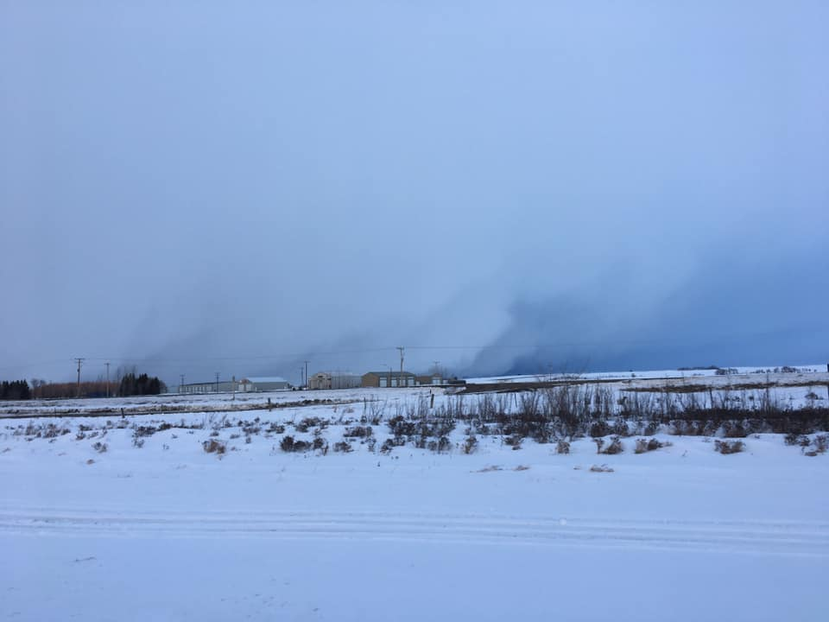 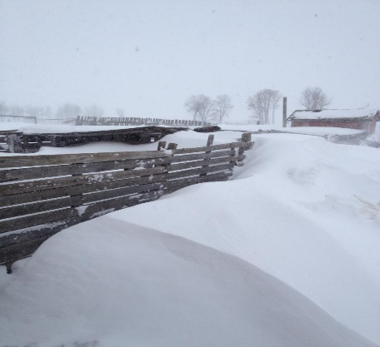

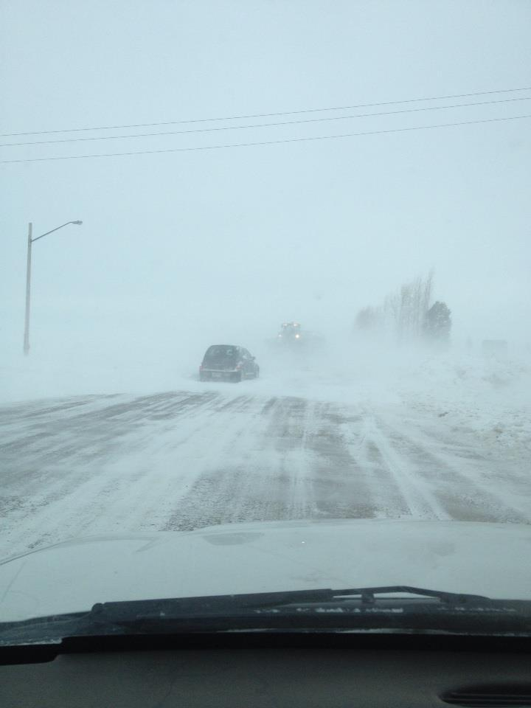 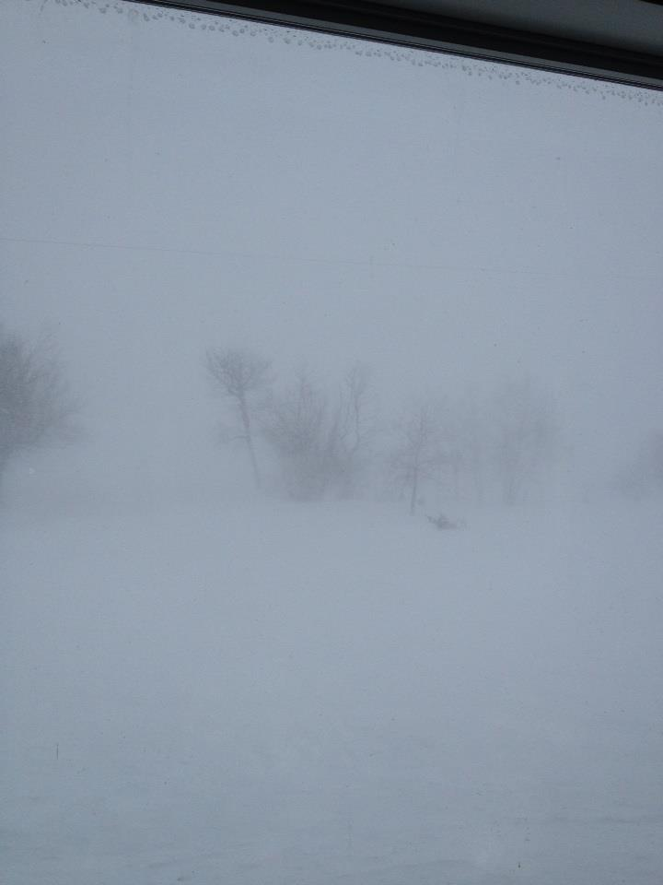

*General Precautions to take*

Being prepared for winter should not wait until the last minute. To ensure that you, your family, animals and vehicles are ready for the cold winters,

* Winterize your home
  + Ensure that you have enough of a fuel source to heat your house
  + Ensure that your house is well insulated (windows, doors etc.)
* Winterize your vehicle
  + Antifreeze is full
  + Windshield washer fluid is rated for -40
  + An emergency kit including
    - Shovel
    - Blanket
    - Candles
    - Matches (waterproof), lighter
    - Food
    - Sand (traction and weight if you should spin out/get stuck)
    - First aid kit
    - Antifreeze/windshield washer fluid
    - Tow rope
    - Plastic water bottles (full replace every six months) (plastic so if they freeze they won’t shatter)
    - Window scrapper

Your emergency kit at home should contain the same essential supplies as your spring/summer as well as any personal documents that may be required.

* *REMEMBER TO SWITCH OUT SEASONAL CLOTHING TO ENSURE YOUR SAFETY!!*

**Before a Blizzard or Winter Storm Hits**

If a blizzard or heavy blowing snow is forecasted, taking precautions and planning ahead will ensure your safety. Here are some tips to use;

* String a ‘lifeline’ between your house and most frequented buildings if you absolutely have to go outside during a storm
* Insulate the outside of your house by
  + Banking snow along the base (ensure you remove to prevent water leaking when it thaws)
  + Square straw bales can also be used
* Insulate windows and doors
  + Insulation to cover windows, and door frames
  + Plastic cover windows with the heat shrink plastic (available at all hardware stores etc.)
* If you have to go outside dress accordingly;
  + Toque
  + Mitts
  + Moisture wicking outer clothing
  + Insulated boots (in Saskatchewan winters you should have winter footwear rated to -40)

If you need to travel take the following precautions;

* Let someone know your plans – NOT the person you’re traveling with
* Ensure you have your emergency kit in the vehicle
* Travel during the day
* Your fuel tank is full
* Extra way to provide warmth if you should get stuck.
* If you do get stuck
  + Remain calm and stay in your vehicle
  + Allow fresh air into the vehicle by opening the window slightly on the sheltered side (away from the wind)
  + You can run your car engine every 10 minutes every half hour.
  + Check your exhaust pipe to ensure it is not plugged with snow.
  + If you do try to shovel your way out, do not over exert yourself take frequent breaks.
* If you have a fireplace or wood stove, be sure to stock up on dry, seasoned wood.

**Extreme Cold and your Health**

Extreme cold temperatures can be hazardous to people & animals, but can also help to limit the spread of pests/disease. When wind is experience with cold temperatures, the impact is even more pronounced.

When your body temperature drops decidedly lower than normal and as wind speed increases, heat can leave your body more rapidly. This may lead to serious health problems.

What should you do during extreme cold

* Stay out of the cold
* If you have to go out;
  + Dress appropriately
    - Toque
    - Scarf or knit mask to cover face/mouth
    - Sleeves that are snug at the wrist
    - Mittens
    - Water resistant coat and boots
    - Several layers of loose-fitting clothing
    - Wool, silk or polypropylene inner layers of clothing closer to the body will retain more heat than cotton
    - Avoid exertion as your body is already working hard to stay warm
    - If you must do heavy work outside, work slowly and dress warmly
  + Stay dry
  + If you start shivering that is the first sign that your body is losing heat
  + Keep hydrated
  + Keep moving
  + Understand what windchill is
  + Watch for signs of frostnip, frostbite and hypothermia
  + The use of alcohol, tobacco and certain medications will increase susceptibility to cold
  + Some people are more susceptible to the cold, particularly children, the elderly and those with circulation problems.

*Signs of Cold Emergencies*

Hypothermia

* Being cold over a prolonged period of time can cause a drop-in body temperature
* Shivering, confusion and loss of muscular control (i.e. difficulty walking)
* It can progress to a life-threatening condition where shivering stops or the person loses consciousness. Cardiac arrest may occur.

Frostnip

* Weaker form of frostbite where only the skin freezes
* Skin takes on a yellowish or white colour, but remains soft to the touch
* Accompanied by a painful tingling or burning feeling

Frostbite

* A more severe skin condition, where both the skin and the underlying tissue (fat, muscle, bone) are frozen
* Skin appears white and waxy and is hard to the touch
* No sensation – the area is numb or tingling

*Treatment of Cold Emergencies*

Hypothermia

* Get medical attention immediately
* Lay the person down and avoid rough handling, especially if they are unconscious
* Get the person indoors
* Gently remove wet clothing
* Warm the person gradually and slowly, using available heat sources

Frostnip

* Do NOT massage or rub the affected area
* Slowly warm up the area using body heat (hand) or some warm water
* Do not use any form of direct heat which can burn the skin
* After the area has been warmed, do not re-expose to the cold

Frostbite

* Frostbite can be serious and result in amputation, seek medical help!
* Do not rub or massage the area
* Do not warm the area until you can ensure it will stay warm
* Warm the area gradually, use body heat, or warm water (40°C - 42°C) and avoid direct heat which can burn the skin.

**Preparing for an outage**

Power outages can occur during a winter storm, blizzard, ice storm. Be prepared for this by;

* Install a non-electric stove or heater
* Choose heating units that not dependent on an electric motor, electric fan or some other electric device to function
* If you have a fireplace or wood burning stove, clean your chimney annually
* Program **310-2220** **SaskPower Outages,** into your cell phone
* Stock up on blankets for added warmth
* If you have a landline, keep a corded phone in the house
* Plug sensitive electronic equipment (Computer, TV’s etc.) through surge protector power bars.
* Purchase a generator
* ***Remember - If you have life-sustaining equipment, you can register it with SaskPower and be notified of a planned power outage.***

**Preparedness for your pets**

Your pets and livestock safety are also your responsibility, before during and after an emergency. Include a plan for your animals in your family emergency plan.

* If there is an emergency and your pets are outdoors, bring them inside immediately.
* Ensure there is adequate feed for your livestock (outside animals tend to eat more feed to stay warm in the winter), including bedding and shelter

If you are required to evacuate, you may not be able to take your pets with you, try and have a plan created that includes a place you can go to stay that will take pets,

* If your pet needs to go outside during a storm, check their paws upon return to make sure that ice is not building up between the toes and that salt or ice melt is NOT irritating their skin.
* Check under your vehicles hood before starting as cats and other small animals climb inside to stay warm.
* Keep antifreeze in a closed air tight container, it is extremely toxic to animals,
* Watch for frostbite and signs of hypothermia as well.

You may want to have a kit in place for emergency supplies for your pets. This may include but not be limited to;

* Food
* Water
* Blanket
* Sturdy leash/harness
* Carrier for transporting small pets
* Litter box and litter
* Current photo of your pet if it should become lost

Special care for other pets

*Birds*

* Transport birds in a sturdy cage
* Avoid excessive noise
* Keep them warm
* Enough feed and water on hand for 72 hours

*Reptiles*

* Snakes can travel in a cloth bag/pillow case, but will need their own cage at point of destination
* Large bowl – to allow snake to soak in
* Heating pad or hot water bottle to make your pet snake more comfortable

*Small animals*

* Many small animals can be transported in their cages as long as they are comfortable with dry bedding and have food and water

*Fish*

* Use their own bowl and water, ensuring to cover the top with plastic or some sort of lid to prevent water from spilling
* If the fish are in a large tank that cannot be transported, a container and water that is from their tank, cover the opening to ensure no water spills.

**Preparedness for Livestock**

On a farm, generally the effects of sever storms – thunder, lightening, winter etc. on livestock are lessened by moving animals to avoid the storm. Some ranchers/farmers have barns to shelter animals in, but many do not and have to rely on portable shelters and the use of bush to protect their animals from the worst of the storms.

Ensure there is plenty of feed available to the livestock and move them to a more sheltered area, feed them in a relatively sheltered area on a regular basis., and ensure there is ample bedding in there as well. Most livestock can stay hydrated with eating snow, as well as knowing how to break open ice with their hooves, also heading to a water bowl, trough or slough that is kept full on a regular basis throughout the year.

In the spring, summer and fall months, ensuring there is water available to the livestock is a necessity. Having a water bowl, or some other form of water available year-round is the best solution to water availability.

**Evacuation**

If you are required to evacuate the area, ensure that your animals are taken care (feed, water etc.) (this should be included in your evacuation plan as well)

Knowing the quantity of livestock you have, the location of all of them (summer pasture/winter pasture), will be essential in recovery or separation of livestock if they should happen to get out and in with other livestock.

Links

The following links will be able to provide more in-depth information for all the previous information discussed above.

Environment Canada - <https://www.canada.ca/en/environment-climate-change/services/types-weather-forecasts-use/public/criteria-alerts.html#severeThunderstorm>

Severe Weather Preparedness - <https://www.getprepared.gc.ca/cnt/rsrcs/sfttps/tp201012-en.aspx>

SaskPower - <https://www.saskpower.com/> - Select drop down menu, Outages, Emergency Preparedness

Cold-weather power outages: what to do before, during & after - <https://www.cooperators.ca/en/Resources/stay-safe/winter-power-outage-tips.aspx>

72 Hour Kit - <https://www.getprepared.gc.ca/cnt/rsrcs/pblctns/yprprdnssgd/index-en.aspx>

The Weather Network - <https://www.theweathernetwork.com/ca>

SaskAlert - <http://emergencyalert.saskatchewan.ca/>

Saskatchewan Government Website - <https://www.saskatchewan.ca/>

Livestock preparedness - <https://www.getprepared.gc.ca/cnt/rsrcs/pblctns/frm-nmls/index-en.aspx>

**Forms/Checklists**

The Following Forms/Checklists can be copied/printed for your use to create you home emergency plan

Emergency Information

|  |  |  |
| --- | --- | --- |
| Family Members | Address: Rural/Civic/Town | Muster Point |
|  |  |  |

Contact Information:

|  |  |  |  |  |
| --- | --- | --- | --- | --- |
| Family Member | Cell Phone | Work/School etc. | Home # | Email Address |
|  |  |  |  |  |
|  |  |  |  |  |
|  |  |  |  |  |
|  |  |  |  |  |
|  |  |  |  |  |
|  |  |  |  |  |
|  |  |  |  |  |

Evacuation Route:

|  |
| --- |
|  |
|  |
|  |
|  |
|  |
|  |
|  |
|  |

Copies of Important Documents

|  |  |  |
| --- | --- | --- |
| Marriage License | Wills | Photos of family Members |
| Birth Certificates | Licenses |  |
| Passports | Insurance |  |
|  |  |  |

* ***Ensure that you are updating your photos, especially of your young children as they change so fast.***

Emergency Information (procedures in place for what emergency protocols are)

|  |  |  |  |  |
| --- | --- | --- | --- | --- |
| Contact Name | Work | Daycare | School | Contact Number |
|  |  |  |  |  |
|  |  |  |  |  |
|  |  |  |  |  |
|  |  |  |  |  |
|  |  |  |  |  |
|  |  |  |  |  |
|  |  |  |  |  |

Outside Emergency Contacts – Evacuation Purposes

|  |  |  |  |  |  |
| --- | --- | --- | --- | --- | --- |
| Name | Relation | Home Number | Cell Number | Email Address | Home Address |
|  |  |  |  |  |  |
|  |  |  |  |  |  |
|  |  |  |  |  |  |

Special Health Needs for Family Members

|  |  |  |  |  |  |  |
| --- | --- | --- | --- | --- | --- | --- |
| Name | Allergies | Special Equipment | Medical Conditions | Medical History | Vaccinations | Surgeries |
|  |  |  |  |  |  |  |
|  |  |  |  |  |  |  |
|  |  |  |  |  |  |  |
|  |  |  |  |  |  |  |
|  |  |  |  |  |  |  |
|  |  |  |  |  |  |  |

Emergency Contact Information

|  |  |  |
| --- | --- | --- |
| Emergency Service | Contact Number | Local Number |
| Police | 911 |  |
| Fire | 911 |  |
| Ambulance | 911 |  |
| Hospital |  |  |
| Clinic 1 |  |  |
| Clinic 2 |  |  |
| SaskPower | 310-2220 |  |
| Poison Control | 1-866-454-1212 |  |

Location

|  |  |
| --- | --- |
| Fire Extinguisher |  |
| Smoke Detectors |  |
| Carbon Monoxide Detectors |  |
| Electrical Panels |  |
| Gas Valve |  |
| Water shut off Valve |  |

Emergency Kits

|  |  |  |
| --- | --- | --- |
| **Home** | **Vehicle** | **Pets** |
| Water – 2 litre/person | Water | Food – 3-day supply |
| Non-perishable food items | Whistle | Water – 3-day supply |
| Manual Can opener | Warning light or road flares | Containers for food & water |
| Crank or battery-operated Flashlight | Crank or battery – operated flashlight | Paper towel |
| Crank or battery-operated Radio | Crank or battery-operated Radio | Can opener |
| First aid kit | First aid kit | Blanket |
| Extra keys for house & Vehicles | Blankets | Leash/harness |
| Cash – small bills | Candle, matches, lighters | Cat litter & pan |
| Copy of emergency Plan | Food that wont spoil or explode if frozen | Dry bedding (rabbits’ birds etc.) |
| Infant formula | Shovel | Plastic bags (waste) |
| Prescriptions / medication if required | Scraper/snow brush | Carrier for transporting pets |
| Equipment for members with disabilities | List of Contact numbers | Heating pad/hot water bottle for reptiles |
| **ADDITIONAL ITEMS** | **ADDITIONAL ITEMS** | Medication/medical records |
| 2 additional litres of water/person | Antifreeze, windshield washer fluid (according to season) | Vaccinations &/or microchip information |
| Candles, matches or lighter | Fire extinguisher | Current photo of pet(s) |
| Change of clothing, footwear for all members of household | Maps | Copy of license |
| Sleeping bag or extra blankets | Sand, salt, kitty litter | Muzzle (if required) |
| Toiletries | Tow rope |  |
| Hand sanitizer | Jumper cables |  |
| Utensils | Paper towel/wipes |  |
| Garbage bags |  |  |
| Toilet paper |  |  |
| Basic tool kit |  |  |
| Duct tape |  |  |
| Paper Towel/wipes |  |  |