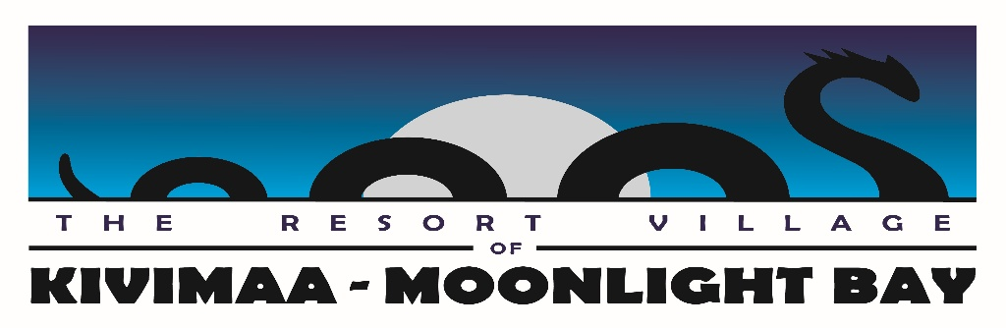

**Summer Student Job Opportunity – Resort Village of Kivimaa-Moonlight Bay**

Are you looking for a hands-on summer job where you can enjoy the outdoors while making a difference in your community? The Resort Village of Kivimaa-Moonlight Bay is seeking a reliable and hardworking **Summer Student** to help maintain our beautiful park and beaches.

**Responsibilities:**

* Grass cutting, whipper snipping, and general lawn care
* Painting and minor maintenance tasks
* Assisting with hauling garbage and keeping public spaces clean
* Supporting other park upkeep activities as needed

**Requirements:**

* Must be a student (high school or post-secondary) returning to studies in the fall
* Ability to perform physical outdoor tasks in various weather conditions
* Strong work ethic and attention to detail
* Ability to work both independently and in a team environment

**Details:**

* **Location:** Resort Village of Kivimaa-Moonlight Bay Turtle Lake
* **Hours:** Available to Work Weekdays (flexible)
* **Wage:** Competitive hourly pay

If you're eager to work in a vibrant outdoor setting and contribute to keeping our park beautiful, we'd love to hear from you!

**Apply today!** Contact Village office @ (306) 845-3336 for more information or to submit your application to rvkmb@myaccesss.ca.