|  |  |
| --- | --- |
| WILDFIRE PREPARATION | Fires are a natural hazard in any forested and grassland region in Canada. The regions with the highest wildfire occurrence are British Columbia, and the Boreal Forest zones of Ontario, Quebec and the Prairie Provinces, the Yukon and Northwest Territories.  R.V. Of Kivimaa-Moonlight Bay Website:  [rvkmb@myaccess.ca](http://www.rmofturtleriver.com)  Office phone # (306) 845- 3336 |

|  |  |
| --- | --- |
|  | Page |
| Table of Contents | 1 |
| Wildfires | 2 |
| Up-to-date Information | 2 |
| Wildfire Facts | 2-3 |
| * Pictogram – Wildfire only have 2 causes | 2 |
| Saskatchewan Ministry of Environment | 3-5 |
| Pictograms | 3-5 |
| * Wildfire Assessment | 3 |
| * Myth vs Fact | 4 |
| * Finding Wildfires | 4 |
| * How Saskatchewan Fights Wildfires | 4 |
| * Benefits & Risks of Wildfires | 4 |
| * Saskatchewan Wildfire Priorities | 5 |
| * Valuables we Protect | 5 |
| Do not be the cause of Wildfire | 6 |
| Preparing for Grass/Wildfires | 6 |
| Assessing your Property | 6 |
| General Precautions to take | 6-7 |
| Responsibility | 7 |
| The Practice of Stop Drop & Roll | 7-8 |
| * Stop | 7 |
| * Drop & Cover your Face | 7 |
| * Roll | 7-8 |
| Reducing the likelihood of Grass/Wildfire Damage | 8 |
| If a Grass/Wildfire is approaching your Home/Community | 9 |
| Evacuation | 10 |
| * When to Evacuate | 10 |
| * Ordered to Evacuate | 10 |
| After Grass/Wildfire | 10-11 |
| Extended Power Outage | 11-12 |
| Links | 14 |
| Forms | 15-17 |
|  |  |

**Wild Fires**

Forest fires or wildfires are common occurrences from May to September and can cause extensive damages and put lives in danger. Natural Resources Canada’s *Canadian Wildland Fire Information System (link at end of booklet)* provides detailed information about wildfire conditions across Canada.

**Up-to-date Information**

The *Canadian Interagency Forest Fire Centre* is a joint initiative of, the federal, provincial and territorial governments. During the fire season the Centre operates 24 hours a day, 7 days a week to provide up-to-date reports on the fire situation across Canada. It also coordinates the sharing of firefighting resources such as aircraft and firefighters.

**Wildfire Facts**

* Approximately 8,000 wildfires occur annually in Canada.
* Average area burned in Canada is 2.5 million ha/year.
* 45% of all fires are caused by lighting strikes, due to the fact they mainly occur in remote areas, and often in clusters, these fires represent about 81% of total area burned.
* 55% of all fires are the result of humans. They occur in more populated areas and are usually reported and extinguished quickly.

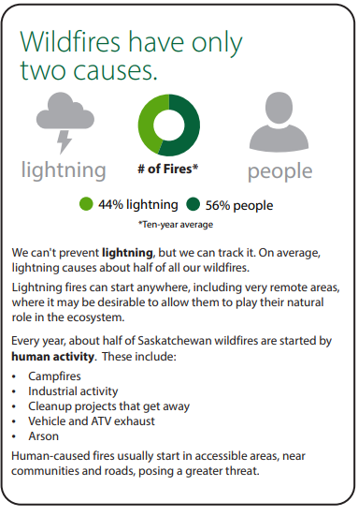

Each province & territory are responsible for managing their wildfires in cooperation with local authorities, in some cases they may request aid from the federal government.

*The Government of Canada’s Government Operations Centre (GOC) monitors the wildfire situation across the country. The GOC coordinates the federal government’s response to events of national interest such as wildfires that may affect the safety and security of Canadians or critical infrastructure. Should a provincial or territorial government request federal assistance to deal with a wildfire then the GOC would coordinate that response.*

**Saskatchewan Ministry of Environment**

The ministry assesses every wildfire and makes a decision about the best way to manage each fire considering many factors, including:

* What is threatened
* Firefighter safety
* Current and forecast weather
* Fire behaviour
* Fuel types

Wildfires that threaten human life and communities are always the governments top priorities, followed by critical public infrastructure, major industrial infrastructure, commercial timber, remote structures and natural resources.

* *See attached Maps*

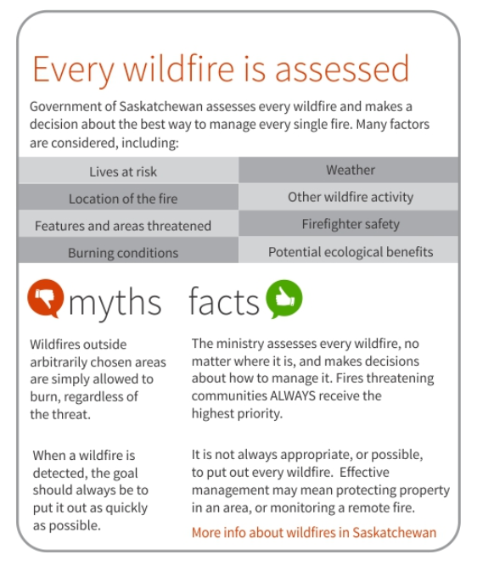

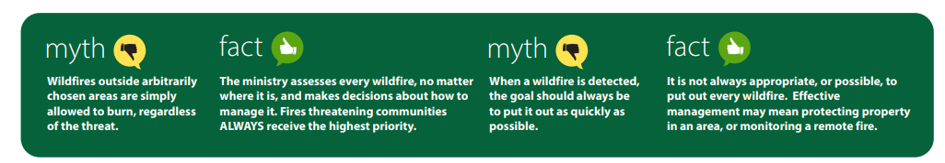

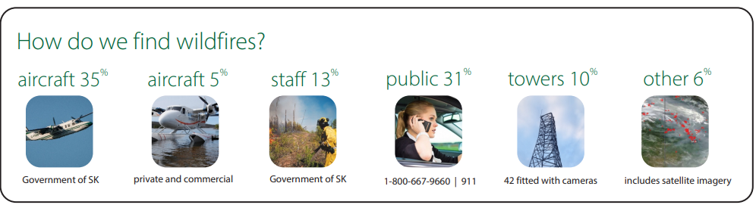

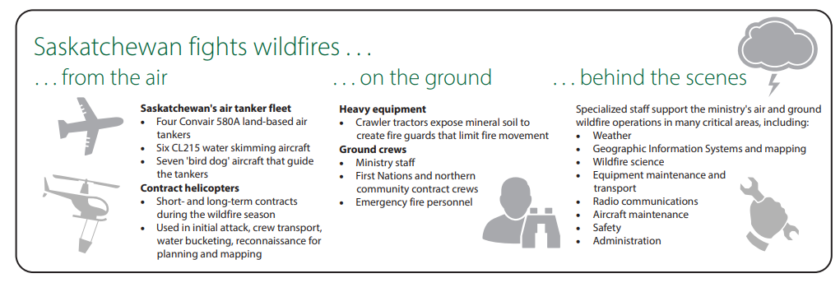

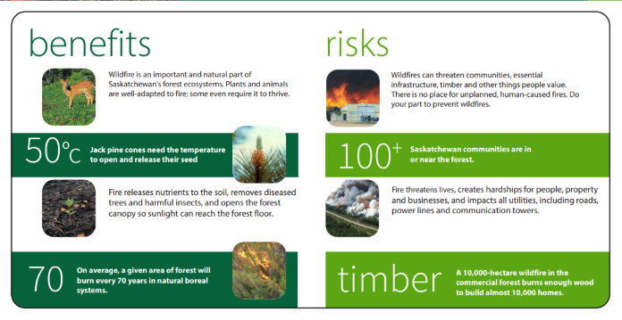

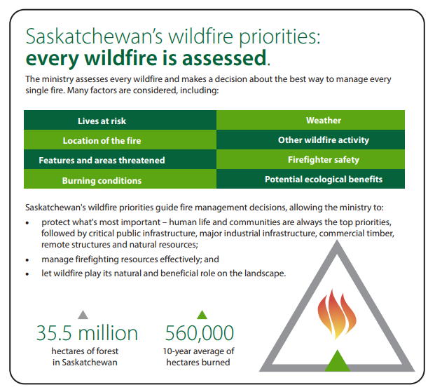

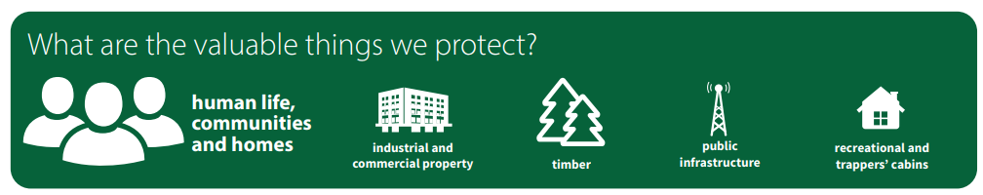

* The sooner a wildfire is called in, the quicker the fire departments can deal with it and put the blaze out. If you spot a wildfire, report it to 911.
* If you are planning a controlled burn call the burn line at **1-866-404-4911**

Do not be the cause of a wildfire!

* Chimneys should be constructed to meet current building code requirements and should have approved spark arrestors
* Burn barrels and Fire pits should be located well away – no less than 3 meters (10 feet) from logs, stumps and other combustible materials and no less than 15 metres from buildings.
* Should have proper ventilation and screens to adequately cover the top of burn barrels, fire pits etc.
* Never leave a fire pit/burn barrel unattended
* Do not burn or have a fire in windy conditions.

***REPORT A WILDFIRE CALL 1-800-667-9660 or 911***

*If you have information about arson please call the TIP line @ 1-800-667-7561 or #5555 from your SaskTel cell phone*

**Preparing for Grass/Wildfires**

Living in rural or urban interface area exposes the residents to greater risk for grass/wildfires. It is the responsibility of the property owner(s) to protect their homes and property from the risk of burning. By doing this, it will aid the municipal and provincial fire fighters in reducing and preventing loss due to a grass/wildfire.

*Assessing your Property*

In order to protect your property, assess it to determine the risks. *You can find links to the forms in the links section of this booklet. The forms will be attached at the end of this booklet is as well.*

*General Precautions to Take*

Whether you live in a high-risk area for grass/wildfire, or even if you travel to areas that are high-risk having a plan and knowing the area that you are traveling to emergency plans are, is good to have.

The following is list of precautions to take;

* Prepare a family plan
  + Keep this plan updated and in an easy to find place (with your emergency kit)
  + Photocopy your plan or add it to your notes on your iPhone, android, iPad or tablet.
* Include in your plan
  + Contact information
  + Copies of important documents
    - Will
    - Insurance policies
    - Contracts deed
    - Passport
    - SIN cards
    - Immunization records
    - Bank information
  + Evacuation routes – out of house and out of yard
  + Your local Emergency Planning Committees evacuation centre(s)
  + Outside contact information (extended family or friends)
    - Phone numbers and address
  + How to communicate with immediate family members should you become separated.
    - Ensure children know mom and dads phone numbers
    - If possible, have them know their grandparents/aunt/uncles phone numbers
* Prepare an emergency kit for;
  + Home (enough for all members of the household)
  + Pets
  + Car
  + Grab and go kit
* Trim/Repair/Fill
  + Branches
  + Shingles
  + Fill troughs barrels etc. with water to secure in place
* Make Plans for livestock
  + Water & feed
  + Shelter
  + Transportation (in the event flood, fire, etc.)

*Responsibility*

Although the RM of Turtle River No.469 and the Village of Edam have an Emergency Planning Committee that has prepared for these types of situations, it is also your responsibility to protect you and your family including your pets and livestock.

Agencies from all levels of government can do their jobs efficiently if each one of us takes a personal responsibility for preparedness. By ensuring we are prepared, our family friends and neighbours are prepared, and being able and willing to help the aforementioned it will help to reduce the devastating effects of disasters.

*The Practice of Stop-drop-Roll*

The practice of Stop Drop and Roll, has been taught to children for many years now. Stop Drop and Roll & cover your face, is used when a persons clothing catches on fire. In order for a fire to burn it requires three (3) elements;

* Heat
* Fuel
* Oxygen

Rolling reduces the flame (heat), and its ability to reach other parts of your clothing (fuel), rolling also smothers (oxygen) the flames.

These three elements together cause the chemical reaction known as Fire.

*Stop –* if you should happen to catch fire, whether at home, camping or elsewhere, do NOT run. Running provides the flames with oxygen, and the ‘breeze’ created by running will fan the flames.

*Drop & cover your face* – dropping to the prone (face down) position and covering your face immediately reduces the body surface area exposed to the flames, as well as smothering the oxygen that is available to the flames. Covering your face will also aid in burns to the face. Fire burns upwards, so by dropping to the prone position, you reduce the fire’s ability to burn upwards towards the head/face.

*Roll* – clothing is a source of fuel for fire/flames, as the entire body is most often completely covered by clothing there is a lot of fuel source available. The roll technique ensures that all clothing that may be on fire is smothered (depriving the oxygen). Rolling front to back will effectively ensure that all sides of the body are extinguished. Continue to roll until fire is completely extinguished on your body.

The Stop Drop and Roll technique is only required when your body is on fire, do NOT stop drop and roll if a fire alarm sounds or are ordered to evacuate.

*Reducing the Likelihood of Grass/wildfire Damage*

To reduce the risk to you and your family and property for damage from a grass/wildfire being properly prepared is essential. Being properly prepared though does NOT guarantee that you and your property will be unharmed in the event of a fire incident, it will greatly reduce the risks.

Prepare yourself and property by taking the following steps;

* Reduce all sources of fuel such as
  + Tall grasses
  + Shrubs
  + Tall trees
  + Other sources of vegetation
  + Store firewood and other sources of combustible materials at least 30 feet away from any buildings.
  + Homes that are situated on a slope, the 30-foot safety zone should be increased accordingly as fire spreads more rapidly uphill.
* Home –
  + use fire resistant materials to build or replace any flammable materials, metal, tile, composite or asphalt shingles for roofing materials and brick or stucco walls are the most fire-resistant materials.
  + Enclose the undersides of decks, porches, eaves, soffits & fascia
  + Double pane windows and tempered glass are recommended for large windows in high risk areas.
* Park boats, campers and other equipment in an enclosed area away from your home
* Ensure easy access to your property for any emergency vehicles that may be responding
* Keep your yard/lawn healthy, cut and watered, it is a natural firebreak
* Clean the roofs, gutters and eaves of the house and other structures
* Keep trees and shrubs at least 3 meters from your BBQ, and NEVER leave your BBQ unattended.
* If you are burning outside ensure you take the following steps
  + Call 1-866-404-4911 and notify them of the date you are planning on burning
  + Keep the following on hand while burning
    - Shovel
    - Water – pail, tank, barrel
* Keep fire extinguishers in all heavy equipment.
* **If the fire department is dispatched to a call on your property, you WILL be billed for services, whether they are required or not. As per *Bylaw No. 6-2019.***

**If a Wildfire/Grass fire is approaching your Home or Community**

If you see a fire approaching your home or community, report it immediately to **9-1-1!!**

If and only if it is safe to do so before help for the fire arrives, you should try and take the following steps;

* Monitor the radio, TV or SaskAlert App or website *(found in the links section of this booklet)*
* Dress safely by donning the following clothing
  + Socks
  + Close toed footwear (leather boots, shoes etc.)
  + Pants (cotton, linen and silk catch on fire quickly, and burn rapidly)
  + Long sleeve shirts
  + Gloves
  + Bandanas (cover face to aid in too much smoke inhalation)
* Close all windows and doors
* Cover vents, windows and any other source of intake into the house/building with duct tape or pre-cut plywood.
* Disconnect automatic door openers, ensuring that manual opening is still available
* Close all garage doors
* Park your vehicles so that when it comes time to leave you can ‘nose’ out onto the street/road
* Pack your 72-hour kit, any extra valuables that you may need into your vehicle, keeping your windows closed.
* Turn off all sources of natural gas, propane etc.
* Turn on all lights in your house, garage, yard, this is to aid in the event that smoke is entering your house and visibility is limited.
* Move all combustible materials away from doors and windows
* Evacuate your family, pets and livestock when ordered to do so, or if you feel the threat is to great.
* *Remember – if you are in a burning structure and trying to evacuate, the lower to the ground you are the better the chances of escaping are. Smoke is not as thick at ground level and visibility is somewhat better.*

**Evacuation – When & How**

When an emergency occurs, and there is a significant threat posed to the community or residents in the rural areas, Council will need to declare an emergency, and the Emergency Operations Centre will be activated.

*When to Evacuate*

* Evacuate only when instructed to do so by your Emergency Planning Committee members
* If ordered to evacuate, listen to media reports, check the SaskAlert App to learn about areas being evacuated and which routes are the safest to take.
* Evacuation orders are broadcast through the media or delivered directly to the affected persons homes and businesses by any of the following;
  + Emergency Planning Committee
  + Emergency Responders (Fire Department, RCMP, etc.)
  + Council Members
* If notice to prepare for an evacuation is given, ensure that you have all of your essential items ready to go, (Emergency Kit etc.)

*Ordered to Evacuate*

* Ensure that you have your family emergency kit and important documents (Medical and vaccine information)
* Check with your neighbours to see if they require assistance, remember – Protect yourself and your family first.
* Wear comfortable and appropriate clothing and footwear
* Check that arrangements made for pet & livestock (should be done when creating/building your emergency kit) is still in place
* Shut and lock all doors and windows including barn doors and gates.
* Shut off water supply, natural gas and power to all buildings and out buildings
* Evacuate via the route exactly as directed.
* Remain calm and do not speed, obey official directions as some roads may be closed or rerouted.
* DO NOT TAKE SHORTCUTS
* Report to designated reception centres, if you have an alternate location to stay, still call and report in to the Reception centre so that they know your location and that you and your family are safe and not sending volunteers out to search for you.

*After a grass/wildfire*

After a wildfire, the likelihood of natural hazards such as landslides, severe soil erosion and flooding increase significantly. These hazards can increase the risk to life, property & infrastructure.

Before returning to your home/property;

* Check with fire officials before attempting to return home
* If you have a fire, get your neighbours to help fight it
* Maintain a fire watch for several hours after it has been extinguished to ensure it doesn’t reignite.
* Contact 911 if any danger is perceived
* Take photos or videos of the damage resulting from the fire
* Contact your insurance agent & local government authority to inquire about PDAP assistance.

**Extended Power Outage**

Power outages are often times, a side affect of the Severe Storm, no matter the season. Most times an outage will be over almost as soon as it begins. Some power outages can last much longer, especially in rural areas. During a power outage, you may be left without heating, cooling of your house, no lighting, hot water and no running water.

In order to be better prepared in the event of a power outage here are some steps you and your family can take to be ready;

* Wood stove or fire place – have the chimney cleared annually, and ensure you have a good supply of wood to last at a minimum of 72 hours.
* Install an emergency generator
* Plug in all sensitive electronic equipment through a surge protector bar.
* If you require electronic life-sustaining equipment, make sure to have a back-up power source.
  + *You can also register your life-sustaining equipment with SaskPower and be notified of planned power outages.*
* Be sure to program **310-2220** into your cell phone
  + This number is dedicated to reporting and updating the public on power outages by SaskPower and is 24 hours.
* If you have a land line, be sure to keep a corded phone in your house, as cordless phones do not work when the power is out.

*When the power goes out and is an unplanned outage;*

* Determine if the power failure is limited to just your house/acreage/farm or if it affects the neighbours. If it is affecting just your property, check the main circuit breaker to see if it has tripped, turn the breaker off and back on again to ensure a good connection.
* If the resetting of the main circuit does not work, contact SaskPower at **310-2220** and report the issue.
* Turn off or unplug and appliances or electronics you were using when the power went out
  + Leave only one light on so you’ll know when the power comes back on.
* Keep fridges and freezers closed, if the power is out for an extended time, be sure to check all food before consuming to ensure it has spoiled.
* Can use lanterns or candles for light during the outage, be sure to;
  + Use proper candle holders
  + Proper kerosene for lanterns
  + Extinguish when no longer required (going to bed, heading outside, etc.)
* NEVER light a fire inside the house, unless you have a wood stove or fireplace installed.
* Make sure your home has a working carbon monoxide detector
  + If it is hardwired to your house’s electrical supply, be sure to check the battery back up

*When power is restored*

* If everyone’s power has returned but your own, there could be a specific problem at your location.
  + Recheck your main circuit breaker even if it appears to be on
  + If power is not restored, call SaskPower @**310-2220**
* Allow the electrical system a chance to stabilize
* Wait 15 minutes before turning up any thermostats
  + Turn the heating system thermostats up first,
  + Reconnect fridge and freezer(s)
  + Turn on other essential appliance and equipment first and wait another 10-15 minutes before turning on the rest.
* Do not enter a flooded basement
* Do not use any electronics that were flooded, including electrical outlets, switch boxes or fuse-breaker panels until they have been cleaned and inspected by a qualified electrician.
* Check your food supplies in the fridge or freezer(s) as well as in the cupboards, for signs of spoilage
  + If the freezer door is kept closed in an extended power outage for 24-36 hours depending on outside temperature, the food should still be frozen.
  + If the food is just starting to thaw, it should be cooked to prevent spoiling and then refrozen.
* As a general precaution, keeping a bag of ice cubes in your freezer can aid you in determining if the freezer was off due to power outage;
  + If the ice melted and refroze, it is a good indication that your food may have spoiled and to check it all out and toss what is no longer edible.
  + WHEN IN DOUBT THROW OUT!
* Reset your clocks, timers and alarms.
* Restock whatever items were used out of your emergency kit.

The decision to implement a fire ban is approved by the Village council members. Dry hot windy springs are when most fire bans are put in place. To determine if a fire ban is in place please contact;

**RV of Kivimaa-Moonlight Bay;**

* Office – 306-845-3336
* Website - [www.rvkmb.com](http://www.rvkmb.com)

Links

The following links will be able to provide more in-depth information for all the previous information discussed above.

SaskPower - <https://www.saskpower.com/> - Select drop down menu, Outages, Emergency Preparedness

72 Hour Kit - <https://www.getprepared.gc.ca/cnt/rsrcs/pblctns/yprprdnssgd/index-en.aspx>

The Weather Network - <https://www.theweathernetwork.com/ca>

SaskAlert - <http://emergencyalert.saskatchewan.ca/>

Saskatchewan Government Website - <https://www.saskatchewan.ca/>

Livestock preparedness - <https://www.getprepared.gc.ca/cnt/rsrcs/pblctns/frm-nmls/index-en.aspx>

Wildfire Facts - <https://www.getprepared.gc.ca/cnt/hzd/wldfrs-en.aspx#:~:text=Wildfire%20facts&text=Approximately%208%2C000%20wildfires%20occur%20each,81%25%20of%20total%20area%20burned>.

Natural Resources Canada – Canadian Wildland Fire Information System - <https://cwfis.cfs.nrcan.gc.ca/home>

Canadian Interagency Forest Fire Centre - <https://www.ciffc.ca/index.php>

Saskatchewan Environment, public health and safety - <https://www.saskatchewan.ca/residents/environment-public-health-and-safety/fire-safety/firesmart-prevent-and-prepare-for-wildfire>

Road Conditions – Saskatchewan Highway Hotline - <http://hotline.gov.sk.ca/map.html>

**FIRE SMART - VIDEO LINK**

**General Overview Video -** [**https://youtu.be/yUzQoqQAafc**](https://youtu.be/yUzQoqQAafc)

**Stubble Burning -** [**https://youtu.be/jiz3TuLwyrA**](https://youtu.be/jiz3TuLwyrA)

**Campfires & Fire pits -** [**https://youtu.be/ryrQBfQxwK0**](https://youtu.be/ryrQBfQxwK0)

**Home Development Guide Video -** [**https://youtu.be/5k7HDONAW1M**](https://youtu.be/5k7HDONAW1M)

**Protect Our Land Video -** [**https://youtu.be/bZcGAGBnZeU**](https://youtu.be/bZcGAGBnZeU)

**Forms/Checklists**

The Following Forms/Checklists can be copied/printed for your use to create you home emergency plan

Emergency Information

|  |  |  |
| --- | --- | --- |
| Family Members | Address: Rural/Civic/Town | Muster Point |
|  |  |  |

Contact Information:

|  |  |  |  |  |
| --- | --- | --- | --- | --- |
| Family Member | Cell Phone | Work/School etc. | Home # | Email Address |
|  |  |  |  |  |
|  |  |  |  |  |
|  |  |  |  |  |
|  |  |  |  |  |
|  |  |  |  |  |
|  |  |  |  |  |
|  |  |  |  |  |

Evacuation Route:

|  |
| --- |
|  |
|  |
|  |
|  |
|  |
|  |
|  |
|  |

Copies of Important Documents

|  |  |  |
| --- | --- | --- |
| Marriage License | Wills | Photos of family Members |
| Birth Certificates | Licenses |  |
| Passports | Insurance |  |
|  |  |  |

* ***Ensure that you are updating your photos, especially of your young children as they change so fast.***

Emergency Information (procedures in place for what emergency protocols are)

|  |  |  |  |  |
| --- | --- | --- | --- | --- |
| Contact Name | Work | Daycare | School | Contact Number |
|  |  |  |  |  |
|  |  |  |  |  |
|  |  |  |  |  |
|  |  |  |  |  |
|  |  |  |  |  |
|  |  |  |  |  |
|  |  |  |  |  |

Outside Emergency Contacts – Evacuation Purposes

|  |  |  |  |  |  |
| --- | --- | --- | --- | --- | --- |
| Name | Relation | Home Number | Cell Number | Email Address | Home Address |
|  |  |  |  |  |  |
|  |  |  |  |  |  |
|  |  |  |  |  |  |

Special Health Needs for Family Members

|  |  |  |  |  |  |  |
| --- | --- | --- | --- | --- | --- | --- |
| Name | Allergies | Special Equipment | Medical Conditions | Medical History | Vaccinations | Surgeries |
|  |  |  |  |  |  |  |
|  |  |  |  |  |  |  |
|  |  |  |  |  |  |  |
|  |  |  |  |  |  |  |
|  |  |  |  |  |  |  |
|  |  |  |  |  |  |  |

Emergency Contact Information

|  |  |  |
| --- | --- | --- |
| Emergency Service | Contact Number | Local Number |
| Police | 911 |  |
| Fire | 911 |  |
| Ambulance | 911 |  |
| Hospital |  |  |
| Clinic 1 |  |  |
| Clinic 2 |  |  |
| SaskPower | 310-2220 |  |
| Poison Control | 1-866-454-1212 |  |

Location

|  |  |
| --- | --- |
| Fire Extinguisher |  |
| Smoke Detectors |  |
| Carbon Monoxide Detectors |  |
| Electrical Panels |  |
| Gas Valve |  |
| Water shut off Valve |  |

Emergency Kits

|  |  |  |
| --- | --- | --- |
| **Home** | **Vehicle** | **Pets** |
| Water – 2 litre/person | Water | Food – 3-day supply |
| Non-perishable food items | Whistle | Water – 3-day supply |
| Manual Can opener | Warning light or road flares | Containers for food & water |
| Crank or battery-operated Flashlight | Crank or battery – operated flashlight | Paper towel |
| Crank or battery-operated Radio | Crank or battery-operated Radio | Can opener |
| First aid kit | First aid kit | Blanket |
| Extra keys for house & Vehicles | Blankets | Leash/harness |
| Cash – small bills | Candle, matches, lighters | Cat litter & pan |
| Copy of emergency Plan | Food that wont spoil or explode if frozen | Dry bedding (rabbits’ birds etc.) |
| Infant formula | Shovel | Plastic bags (waste) |
| Prescriptions / medication if required | Scraper/snow brush | Carrier for transporting pets |
| Equipment for members with disabilities | List of Contact numbers | Heating pad/hot water bottle for reptiles |
| **ADDITIONAL ITEMS** | **ADDITIONAL ITEMS** | Medication/medical records |
| 2 additional litres of water/person | Antifreeze, windshield washer fluid (according to season) | Vaccinations &/or microchip information |
| Candles, matches or lighter | Fire extinguisher | Current photo of pet(s) |
| Change of clothing, footwear for all members of household | Maps | Copy of license |
| Sleeping bag or extra blankets | Sand, salt, kitty litter | Muzzle (if required) |
| Toiletries | Tow rope |  |
| Hand sanitizer | Jumper cables |  |
| Utensils | Paper towel/wipes |  |
| Garbage bags |  |  |
| Toilet paper |  |  |
| Basic tool kit |  |  |
| Duct tape |  |  |
| Paper Towel/wipes |  |  |